Two Days in Yoga
With Ruth White
New Beaconsfield Hall, Station Road, Shipton-Under-Wychwood, OX7 6BQ

Saturday 27th & Sunday 28th February 2021

Whatever your ability, you will be most welcome.
Come and recharge mind, body and spirit.

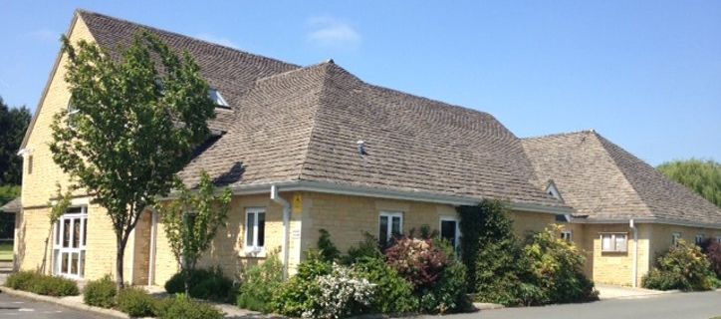

New Beaconsfield Hall is a light and spacious hall with underfloor heating; well suited for the practice of yoga. It is located in the beautiful Cotswold village of Shipton-under-Wychwood, about 4 miles north of Burford, Oxfordshire.

We will have a full day of yoga and will cater for the stiffer body.

SUGGESTED PROGRAMME

 | SATURDAY |  | SUNDAY
9.45  10.00 | Welcome  Yoga | 8.30  10.00 | Teacher Training  Yoga
12.00 | Tea Break or Teacher Training | 12.00 | Tea Break or Teaching Training
1.00 | Lunch | 1.00 | Lunch
2.00 | Talk | 2.00 | Talk
3.00 | Yoga, pranayama, meditation & relaxation | 3.00 | Yoga – Pranayama & Meditation
4.30  5.30 | End of day  Break – Walk or rest | 4.30 | Farewell
6.00 | Talk
7.00 | Supper out at the Wychwood Inn
RUTH was taught by BKS Iyengar and she has been an international yoga teacher for 50 years. Her teaching is a source of inspiration both physically and spiritually.

COST - The full cost for the weekend is £126 (or £68 per day) to include the lunch.
BEDS for Saturday night available, please request.

To Book Please send a non-refundable deposit of £100 for the weekend or £50 for a day. Please make cheques payable to R. White, or please request details to make a payment by bank transfer.

RUTH WHITE . YOGA CENTRE
Lane House Farm, Milton Road, Shipton-under-Wychwood, Oxon OX7 6BD
Tel: 01993 831032 Email: info@yogawithruthwhite.com
www.yogawithruthwhite.com

