Holycombe Retreat Centre
Friday 9th July – Sunday 11th July 2021
with Ruth White
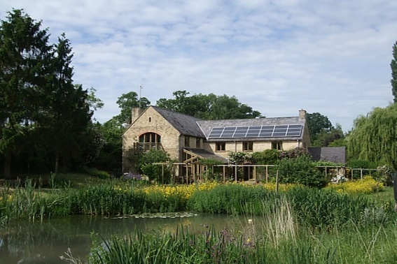
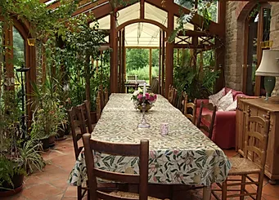
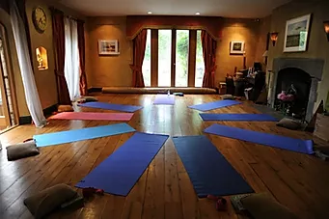
Holycombe, Whichford, Shipston-on-Stour, Warwickshire, CV36 5PH
HOLYCOMBE -Come and join us on this weekend and enjoy the peace and quiet at Holycombe. The weekend is both invigorating and restorative and is in a truly spiritual, relaxing and idyllic place. It stands in 6 acres of peaceful woodland and beautiful natural gardens. From the yoga hall the views are of the natural garden and spring fed lake. Please take a look on their website www.holycombe.com.

Ruth’s teaching is an inspiration both spiritually and physically. Her approach is both practical and spontaneous and she endeavours to meet the ever changing needs of her students.
You don’t have to be good to come; you see it’s not about your body although the body is a perfect, tailor made tool to work with.
It is about the mind and where your attention is.

ACCOMMODATION: They can comfortably accommodate 11 people when sharing plus 3 double bedrooms. Ensuite rooms £25pppn, please request. There is also the opportunity to stay in one of their onsite yurts and glamping facilities.

REQUIREMENTS - Please bring yoga mat, belt, blocks, back arch & blanket if you have them – We supply a few. Plus, own toiletries and towel, Holycombe provide bed linen at £15, or you can bring your own bed linen; duvet cover, pillow slip and sheet.

FEES & BOOKING

Weekend Residents (single) £360.00
Weekend Residents (shared) £280.00
Weekend non-residents £240 (inc all meals except breakfast)
Saturday or Sunday Day guest 9.00am-4pm £88 (inc lunch)
Friday & Sunday Class £88 (inc lunch)
Friday or Saturday 4pm – 9pm £50 (inc dinner)

A non-refundable deposit please with booking of £60, £40 for day guests is necessary to secure a place. The balance of your fee will be due on 3rd June 2021.

To book you will need to call 01608 651189 or email info@yogawithruthwhite.com for bank details.

PROGRAMME

FRIDAY
4.00 pm Welcome
5.00 pm Restorative yoga class
6.30 pm Supper together
7.30 pm Talk – The Breath of Life

SATURDAY
8.00 am Breakfast
9.30 am Postures demonstration & explanation
11.00 am Coffee/tea break
11.30 am Asana practice with attention on feet
1.00 pm Lunch
2.30 pm Practical talk - How our challenges can be used to our advantage
4.00 pm Afternoon tea
4.30 pm Seated postures leading into Pranayama & Meditation
6.30 pm Supper
7.30 pm Talk – Yoga & How to work to release fears

SUNDAY
8.00 am Breakfast
9.30 am Asana class – how to adapt your postures to changing needs
11.00 am Coffee/tea break
11.30 am Postures with attention on core strength
1.00 pm Lunch
2.00 pm Talk – The Art of Relaxation
Followed by Stretch, Pranayama &
Yoganidra
4.00 pm Afternoon tea and departure

MEALS We are bringing our own cooks. The meals will be gluten-free and low sugar, still delicious and we can cater for vegans.

TRAVEL
If you would like a lift or can give one, please let us know.

By Train​
The nearest railway station (five miles away) is Moreton-in-the-Marsh which is on the Oxford-Hereford line. From London you leave from Paddington Station. John will meet the train that arrives at 16.19 on Friday, and take people back for the return train on Sunday at 16.55 Moreton In Marsh to Paddington arriving at 18.29 (subject to change). If you require a taxi from the station please call 07833473436
By Car
As it is in the heart of the Cotswold Countryside you may need directions for the last part of your journey. “Pease see how to find Holycombe” on their website.

